Design Template

Capstone -Accounts Receivable Management Utility
[Robert T Ogden III]
[2/26/2020]
[Version 1]

Contents
A.1 Project Topic, Description and Important Notes 3
A.1. Business Problem to Solve 4
A.2. Software Development Life-cycle Methodology 4
A.3. Deliverables Tied to Methodology 5
A.4. Plan for Implementation 5
A.5. Validation / Verification Methods 6
A.6. Design Environment / Cost 6
A.7. Timeline 7
B.1. User Guide - Setup / Maintenance 8-10
B.2. Proxy Advise 11
B.3 Application Structure 12
B.4. User Guide – UI Walk-through 13-14
B.5. User Roles 15
B.6. User Guide – API Walk-through 16--17
C.1. Class Diagram 18
C.2.Unit Test Plan 19-20
C.3. Results of Test Plan 20
C.4.Specific requirement mappings from WGU task list SECTION B 21-22

A.1 Project topic AND description IMPORTANT REQUIREMENTS NOTES

Accounts Receivable Management Utility
The Accounts Receivable Management Utility is a responsive web page designed to replace, automate, and provide enhance reporting on / automate a largely manual process which manages and tracks asset depreciation data and the capital expenditure process checkpoint data for my company.

Application framework and environment:
- 1 User Interface - Built with React.js Hooks using Google MaterialUI library for a beautiful, responsive and modern design.
- 6 microservices separated by specific business domains with 11 separate API endpoints that use entity framework and Basic HTTP authentication to expose full CRUD database features for the application and anyone wishing to write applications that use the data.

Notes about feature boundaries / security implementation
- User/role management is not a function of this tool, but I built enough to implement role-based security and rights. You will not find user/role maintenance menus in the UI; this is not the purpose of this tool.
- User passwords are created through code the first time the back-end is ran. The passwords are hashed and salted in the database as per industry best practices. In a production environment, hashes and salts would not be stored in source code, but I need a way to simulate passwords in a development environment.
- PRs are driven by a separate system that will be integrating with this app. This applications purpose is not to manage PR data, but to simply give project owners a view of what PRs fall under which ARs. Mock data has been created to simulate this for existing AR records using the PurchaseRequisitionsMock microservice.
- This application’s sole purpose is to allow CRUD actions and reporting for Accounts Receivable data.
- The APIs are all using SSL but it was difficult to simulate SSL in a development react environment without problems and my level of experience. In the true environment, we will address SSL but for now, no SSL in the UI – it is assumed.
- APIs are password protected, base64 basic authentication as per typical APIs.
- Passwords are stored in project properties and leveraged as an environment variable, in both the APIs and in the UI. In a real-world environment, the environment variable exists on this server and the code can use it. This is done to obscure sensitive data such as login and passwords from code.

A.1. Business Problem To solve

The purpose of this project is to give the company’s finance team colleagues a tracking tool to manage capital data and for project owners and directors to track and instantly update the status of their projects to keep automatic synchronization with the finance team. The project owners and directors manage various raised floor activities that incur costs that are approved by finance and this tool serves to streamline that process.
The solution will allow data entry of data that is currently entered into spreadsheets and a centralized location to view, search and report on that data using existing Excel/VBA ODBC linked reports that will be modified to use the new data source that will be built.
Various stages in the current business process require people to manually check the status of requests through looking at the existing data set. There are no notifications, no threshold warnings, no way for users to know that certain way-points have been hit without manually digging through many excel spreadsheets and referring to old emails.
For example, we track depreciation schedules of assets over a 7 year period and have to take action when 90% and 100% of the appropriated cost have been met. This is all done by a human looking over multiple spreadsheets right now and will be totally alleviated by tracking various important phases/dates of the life-cycle of the request and sending providing through the tool so that users have one spot to search for historical information relating to the business processes they initiate.

A.2. Software development life-cycle methodology

This was an agile project through and through:
- We came in with an idea of what we wanted that completely changed into something much better than we originally anticipated.
- We made a wire frame.
- We had frequent customer meetings, almost every other day which formed the direction of the application completely differently than originally envisioned.
- We built a minimum viable product based on customer feedback that can be built on by our staff.
- We had incredible customer feedback with the process and very satisfied customers (and developer)
It was all about the customer and the satisfaction of working with the customer and it turned out to be a great experience.

A.3. Deliverables TIED TO METHODOLOGY
In terms of intangibles, I am delivering 1 UI application built with React.JS, a swarm of 6 back-end C# microservice APIs that the UI will consume to do its job, and one C# xUnit test project for the Users microservice.
Below is a list of all project deliverables represented in section A.7 – Timeline:
- Initial Customer KickOff Meeting
- Wire-frame
- Back-end Prototype
- Front-end UI Prototype
- Halfway Point Meeting
- Finished Back-end MVP (Minimum Viable Product)
- Finished UI MVP
- Connect back End to Front end / Provide Finalized End to End MVP
- Project Finalization Meeting

A.4. PLAN for IMPLEMENTATION

- The next step is to get the application working with our databases at work.
- After that, we need to get the back-end APIs into a our rancher/kubernetes/gitlab cloud system at work. I will have to add yaml configurations that will build and deploy the microservice back-end apis into our three tiered private cloud environment.
- Once that is finished, the UI needs a to also be deployed into our cloud. We need to add an NGINX web server into the container to make it be able to serve up static content and perform routing for the React app.
- We need to obtain an SSL cert and apply it to the UI container so that we are using secure communications.
- At this point, we will be on the network and can remove some of the mock systems that were designed and replace them with calls APIs to various integrated systems.
- We will have to rework the login API calls to work with our in house ADS authentication system.
- We can also start making the application store and send notifications at this point via slack and email and then implement Swagger in all APIs to make the API’s self-documenting.

A.5 VALIDATION / VERIFICATION METHODS
Thanks to agile design, we have been verifying and validating all along the way. Multiple times a week I have been at my end-users desk showing off the new features that are being added.
I went through exhaustive feature testing up to and until the application seemed to be stable. After that, we had a director, an owner, and a finance user test all of the capabilities they requested to satisfaction within the tool. Many suggestions were made and are reflected in the current product.
The finance team has tested a local version of the application in a meeting and agree that the demo looks like it will fulfill their needs and my boss also gave her approval.

A.6 DESIGN ENVIRONMENT / COSTS

The application was written in two languages:
  - Front End – React.Js using NodeJS framework
  - Back End – C# using Microsoft .NetCore 2.2 framework

I used two separate IDEs:
  - Visual Studio Code for React work
  - Visual Studio 2019 Community for C#/.Netcore work

There were no costs / human resources aside from my own effort. I would estimate that I have personally spent 480 hours towards this project outside of work.

A.7 Timeline
Milestone | Start Date | End Date | Duration | Dependencies | Resources
Initial Customer kickoff meeting | 1/10/2020 | 1/10/2020 | 1 hour | N/A | Jennifer Koenig, Debbie Selmo, April Chapman, Antonio Paderi, Robert Ogden
Wire-frame | 1/1/2020 | 1/10/2020 | 2 hours | Initial Customer kickoff meeting | Robert Ogden
Back-end Prototype | 1/10/2020 | 1/16/2020 | 6 days | Wire-frame | Robert Ogden
Frontend UI Prototype | 1/16/2020 | 2/2/2020 | 17 days | Back-end Prototype | Robert Ogden
Halfway Point Meeting | 2/3/2020 | 2/3/2020 | 1 hour | Front End UI Prototype | Jennifer Koenig, Debbie Selmo, April Chapman, David Zak, Jason Ellenberg, Antonio Paderi, Todd Lipscomb, Robert Ogden
Finished Back-end MVP (Minimum Viable Product) | 2/3/2020 | 2/10/2020 | 7 days – ran in parallel with the below task | Halfway Point Meeting | Robert Ogden
Finished UI MVP | 2/3/2020 | 2/10/2020 | 7 days - ran in parallel with the above task | Halfway Point Meeting | Robert Ogden
Connect back End to Front end / Provide Finalized End to End MVP | 2/10/2020 | 2/23/2020 | 13 days | Connect back End to Front end / Provide Finalized End to End MVP | Robert Ogden
Project Finalization Meeting | 2/24/2020 | 2/24/2020 | 1 hour | Finalized End to End MVP | Jennifer Koenig, Debbie Selmo, April Chapman, David Zak, Jason Ellenberg, Antonio Paderi, Todd Lipscomb, Robert Ogden

B.1 USER GUIDE – SETUP / MAINTENANCE

FRONT END SETUP
- You will need to download, install and UPDATE(if applicable) the latest versions of:

- Google Chrome - https://www.google.com/chrome/?brand=CHBD&gclid=EAIaIQobChMI59fVs-Pt5wIVkXZgCh1JtQ33EAAYASABEgJ6pPD_BwE&gclsrc=aw.ds
My organization uses Chrome. This was written for use in Chrome and will not function in IE. The app was not written to consider Internet Explorer.

- Visual Studio 2019 Community Edition - https://visualstudio.microsoft.com/thank-you-downloading-visual-studio/?sku=Community&rel=16
    - Ensure that you have dotnetcore support selected during the installer!!!!

- Visual Studio Code - https://code.visualstudio.com/Download

- .Netcore sdk 2.2 -https://dotnet.microsoft.com/download/dotnet-core/2.2

- Node .js - https://nodejs.org/en/download/

***OPTIONAL - You may need to install the following plugin in chrome to test because react has a known bug in non-production builds where an erroneous CORS errors gets thrown in the f12 browser. This may not be necessary:
https://chrome.google.com/webstore/detail/allow-cors-access control/lhobafahddgcelffkeicbaginigeejlf?hl=en

- Once everything installed and updated, reboot if necessary.
- Open Visual Studio Code.
- From the File menu, select Open Folder and then select /accountsreceviable-frontend and then click the Open button.
- From the Terminal menu, select the New Terminal option and a terminal window will appear at the github
- bottom of the IDE.
- In the terminal window at the powershell prompt, enter the following command:

npm config set registry=http://registry.npmjs.org/

- Next, enter the following command and hit enter:
npm install --verbose --save react-virtualized react-toggle-button react-toastify react-switch react-swipeable-views react-scripts@3.4.0 react-router-dom react-joyride react-draggable react-dom react-datetime react-date-picker react-data-grid-addons react-data-grid react-color react-bootstrap moment local-storage glamor bootstrap axios @material-ui/core @material-ui/pickers @material-ui/lab @material-ui/icons @date-io/moment react-export-excel react-bootstrap xlsx create-react-app react-router

This will take a short amount of time and if you are behind a corporate proxy, this can be a tricky, error-prone step.... See section B.5 – PROXY ADVISE for more information if you are having proxy issues.
- Once the command in step 6 is finished executing, run the following command to start the UI application:
npm run start:dev

You will see the words ‘ Starting the development server...’ in the terminal window. After a minute or so, it will move on and you will see a series of es-linter warnings. At this point, the UI is up and can be reached, but you wont get further than the login page. Now we need to start the backend. (Please leave Visual Studio code open and running)

This would be a fantastic time to witness some error handling! Open the UI – http://localhost:3000

Make an attempt to login using any credentials. After a short timeout cycle, an error message will appear stating there is a problem with the authentication server... Because it hasn't started yet!

Let's start it!
BACKEND SETUP
- Open Visual Studio 2019 Community.
- From the file menu, select File, then Open then Project/Solution.
- Navigate to and select /accountsreceviable-backend/Capstone.sln.

- Under the Debug menu, select the Set Startup Project… option at the very bottom. In the window that appears, ensure you are starting all projects on startup like so: (ORDER IS IMPORTANT)
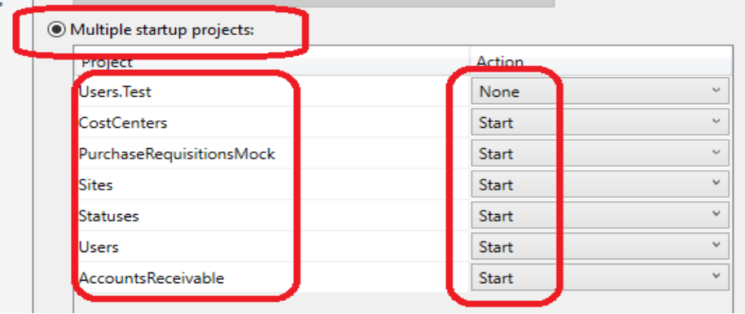

- When your startup projects screen matches the above screen, hit the Apply then Ok buttons.

- Ensure that you are using Chrome in the debugger by changing the settings as shown in the following diagram:
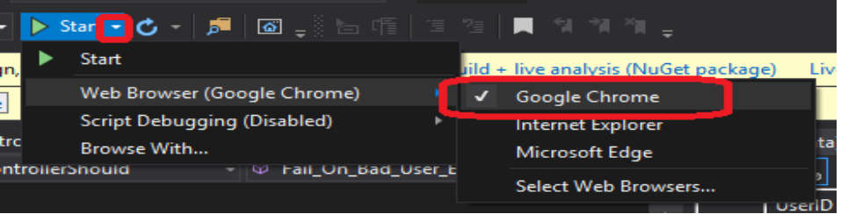

- Click Start (highlighted in blue in the above image) to start the back-end

When you run the back-end for the first time, entity framework will create the databases it needs.

Any time you run it, 6 command prompt windows and 6 web pages will open with login prompts. These are example API requests to the 6 API endpoints.
NOTE: Closing any of the command prompts or Chrome windows will cause the back-end to stop and the front-end will cease to respond.
The API's credentials are ap1us3r / p@ssw0rd1.
Let's take a moment to look at the back-end's error handling. One of the 6 Chrome windows should be opened to https://localhost:6001/API/v1/ar with a login prompt. Enter the above credentials, to see the RESTAPI returning JSON formatted data from the AR table.
Change that link to https://localhost:6001/API/v1/ar/1231312 and you will see what happens when a request that doesn't result in a record being returned occurs. Instead of a crashed API, there is a JSON formatted error message displaying title 'Not found' and passing along an appropriate and standardized HTTP status code (404) the situation.
At this point it’s all running! Move on to section B.6 – APPLICATION STRUCTURE for information about how the applications are organized.

B.2 PROXY ADVISE
If you are behind a corporate proxy, I can’t account for all possible variables and configuration options, but make sure your windows/linux environment variables are set as such:

HTTP_PROXY=http://proxy:port;
HTTPS_PROXY=http://proxy:port;
ALL_PROXY=http://proxy:port;

After that, configure your proxies within NPM:

npm set https-proxy=http://proxy:port;
npm set http-proxy:http://proxy:port;

*NOTE if you still have problem, you may need to set:

npm config set strict-SSL=false

B.3 APPLICATION STRUCTURE

FRONTEND FOLDER STRUCTURE  node_modules - NPM modules. NPM packages get installed here  public – Build folder. This is where production builds will be compiled  src – Source, this is where all of the main source for the application goes  components – This is where individual React components that the pages are made with go  common – This is where shared components will live  context – React useContext hook settings are isolated to this folder  resources – This is where static files and images live | 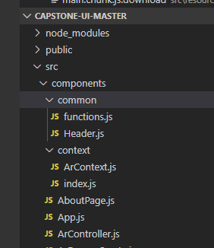
BACKEND FOLDER STRUCTURE  Each project in visual studio is a microservice with the same folder structure:  PROJECTNAME  Controllers – API MVC Controller code goes in this folder  Data – This is where all enums and model classfiles are located  Enum – Enums go in this folder  Models – Models go in this folder  Services* - Services which we inject into our application using dependency injection to utilize business logic reside in this optional folder. | 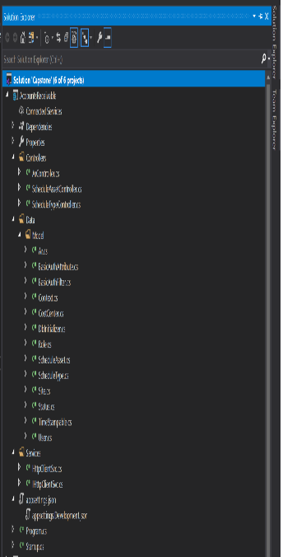

B.4 USER GUIDE – UI Walkthrough

- Navigate to http://localhost:3000/. You will automatically be redirected to http://localhost:3000/login 2
- Enter the credentials for finance user: jkoenig / jkoenig123
- You will be sent to the main page: At the top of of the page is a status bar that displays the status of the currently selected record. Finance users like jkoenig may click this bar to advance the status of the currently selected record. We’ll get to that in a minute, but first let’s discus the other components of the screen
- Immediately below the status bar is the main Accounts Receivable Projects grid where you can view Accounts Receivable(also known as Projects/ARs) records where you can:
- Sort any column by clicking on the column header.
- Filter to search for specific column data by clicking the Filter button in the top right corner of the grid and the entering data in the filter fields that appear.
- Select AR records to edit/delete and change the status of if you are a finance user by clicking on the checkbox on the leftmost side of the grid.
- Inspect popup warnings by hovering over any error icons in the column directly to the right of the checkbox.
- Below the AR Grid is the Purchase Requisition(PR) data grid. This data is simulated and is coming from an external system that we will be integrating with once this app goes into my corporate network. It is mainly there for 'Owners' to be able to view and has no edit/delete/update functionality as it is not needed nor possible for this use case.
- The main source of user control is the speed-dial in the top left corner of the page, to the left to the word Projects in the AR grid. If you mouse hover over the speed-dial, you are given options for actions you may take:
- DELETE AR RECORD
  - Select the checkbox on the left hand side of the record with AR number 5678901(6th from the top) in the AR grid and then mouse hover over the speed-dial.
  - When the menu appears, mouse hover over the Delete AR icon and click it.
  - You will be prompted for confirmation, click YES (DELETE PROJECT) and the record will be removed from the grid.
- EDIT AR RECORD
  - Select the checkbox to the left of the record with AR number 1234567 and then mouse hover over the speed-dial again.
  - Click the Edit AR icon and the Edit AR drawer will appear.
  - In this drawer, finance users may modify anything, owners and directors are restricted as to what edits they may make as per the section B.5 – User Roles below. Make whatever changes you would like, including clicking the status bar to advance the status.
  - To save changes, click the Save Changes button that appears when changes are ready to be saved.
  - Optionally, to exit without saving changes, click the < button in the top right corner of the drawer.
- CREATE AR RECORD
  - Once you've saved or exited the Edit drawer, mouse hover over the speed-dial again and click the Create AR icon.
  - The drawer will open again, but this time the screen will be empty and you will be in create new record mode.
  - Populate all fields appropriately and save the record. (NOTE that you can exit out of the drawer like described above for the edit drawer, but save for now)
  - The current record is unselected when this happens and your new record will be found at the bottom of the list.

- Now let’s manipulate status from the main page:

- Click the checkbox to the left of the new record you just created at the bottom of the AR Grid.
- Click the status bar once to advance the status.
- On the status change from AR Pending to AR Approved, a window will appear asking you if you wish to make the status change.
- Enter an unused AR number and click the Ok button to observe the status change and the AR number get added to the record in the grid.
- Click the status bar to advance the status again to see the normal operation when not making the change from AR Pending to AR Approved.
- In the window that appears, click the Yes button to confirm and observe a typical status change by a finance team member.
- Continue to click the status bar until you cannot anymore, you will be stopped at Close status.

- Time to look at reporting! In the navbar is a Reporting link:
- The option list allows you to select one of three canned reports.
- Selecting a report type will generate a preview at the bottom of the page and download an excel version of the report.

You have just gone through all features a fully privileged finance user! You may log in as a director or owner for a limited experience:
Director log in: achapman / achapman123
Finance log in: jkoenig / jkoenig123
Owner log in: rogden / rogden123

B.5 USER ROLES

Directors – Limited Access  - Can create new records.  - Can filter/search grid  - Can run reports  - Can edit the following fields in records that the current user is listed as a director in:  - Amount  - Total Committed  - Funds Used%  - Actual Completed%  - Purpose of Project  - Opportunities / Benefits to be realized from project  - Risks inherit in project  - Other comment  - ...Cannot edit the remaining fields in the drawer  - Cannot change status from main screen or edit drawer.  - Cannot delete records | Owners – Limited Access  - Can create new records.  - Can filter/search grid  - Can run reports  - Can edit the following fields in records that the current user is listed as a owner in:  - Amount  - Total Committed  - Funds Used%  - Actual Completed%  - Other comments  - ...Cannot edit the remaining fields in the drawer  - Cannot change status from main screen or edit drawer.  - Cannot delete records | Finance – Full Access  - Can create new records.  - Can filter/search grid  - Can run reports  - Can edit all fields in the edit drawer.  - Can change status from main screen or edit drawer.  - Can delete records

B.6 USER GUIDe – API WalkTHROUGH
- There are multiple REST API endpoints that can be accessed to access data or create applications using the data if you have appropriate credentials.
- You can access any of the below HTTP GET methods in a browser and will be asked for credentials when doing so.
- HTTP Post / Delete / Put methods require some basic API understanding and further setup which is beyond the case of this set of instructions, but they are all available and functional and some are used by the UI.
- The credentials to access any of the below GET methods through a browser are ap1us3r / p@ssw0rd

Accounts Receivable Microservice - https://localhost:9001
(Used by the UI to retrieve/create/edit/delete Accounts Receivable data)
GET https://localhost:6001/api/v1/ar/report/1/owner/{id}
GET: https://localhost:6001/api/v1/ar/report/2
GET: https://localhost:6001/api/v1/ar/report/3
GET: https://localhost:6001/api/v1/ar
GET: https://localhost:6001/api/v1/ar/5
GET: https://localhost:6001/api/v1/ar/1234567?arnumber=true
PUT: https://localhost:6001/api/v1/ar/5
POST: https://localhost:6001/api/v1/ar
DELETE: https://localhost:6001/api/v1/ar/5
DELETE: https://localhost:6001/api/v1/scheduletype/5

Cost Center Microservice - https://localhost:9001
(Used by the UI to retrieve Cost Center list data)
GET: https://localhost:9001/api/v1/costcenter/5
GET: https://localhost:9001/api/v1/costcenter
PUT: https://localhost:9001/api/v1/costcenter/5
POST: https://localhost:9001/api/v1/costcenter/
DELETE: https://localhost:9001/api/v1/costcenter/5

Site Microservice - https://localhost:7001
(Used by the UI to retrieve Site list data)
GET: https://localhost:7001/api/v1/site/5
GET: https://localhost:7001/api/v1/site/
PUT: https://localhost:7001/api/v1/site/5
POST: https://localhost:7001/api/v1/site
DELETE: https://localhost:7001/api/v1/site/5

PR Data Mock Microservice - https://localhost:2001
(Used by the UI to retrieve mock PR data)
GET: https://localhost:2001/api/v1/pr/1234567
GET: https://localhost:2001/api/v1/pr/total/1234567
PUT: https://localhost:2001/api/v1/pr/5
POST: https://localhost:2001/api/v1/pr
DELETE: https://localhost:2001/api/v1/pr/5

Status Microservice - https://localhost:4001
(Used by the UI to retrieve Status list data)
GET: https://localhost:4001/api/v1/statushistory/5
GET: https://localhost:4001/api/v1/statushistory/
PUT: https://localhost:4001/api/v1/statushistory/5
POST: https://localhost:4001/api/v1/statushistory
DELETE: https://localhost:4001/api/v1/statushistory/5
GET: https://localhost:4001/api/v1/statuslevel/5
GET: https://localhost:4001/api/v1/statuslevel/
PUT: https://localhost:4001/api/v1/statuslevel/5
POST: https://localhost:4001/api/v1/statuslevel
DELETE: https://localhost:4001/api/v1/statulevel/5

User Microservice - https://localhost:5001
GET: https://localhost:5001/api/v1/phonenumber/5
GET: https://localhost:5001/api/v1/phonenumber
PUT: https://localhost:5001/api/v1/phonenumber/5
POST: https://localhost:5001/api/v1/phonenumber
DELETE: https://localhost:5001/api/v1/phonenumber/5
GET: https://localhost:5001/api/v1/role/5
GET: https://localhost:5001/api/v1/role
PUT: https://localhost:5001/api/v1/role
GET: https://localhost:5001/api/v1/user/5
GET: https://localhost:5001/api/v1/user
GET: https://localhost:5001/api/v1/user/director
GET: https://localhost:5001/api/v1/user/owner
PUT: https://localhost:5001/api/v1/user/5
POST: https://localhost:5001/api/v1/user
POST: https://localhost:5001/api/v1/user/login/rogden
DELETE: https://localhost:5001/api/v1/user/5

C.1 – Class Diagram

I have included a class diagram of the most populous microservice, the Accounts Receivable Microservice with the submission. There are quite a few classes in the image that wouldn’t fit in this document easily. Please look for it in the root of the zip file, its name is AR_Microservice_Class_Diagram.png.

C.2 – UNIT TEST PLAN

The plan of the unit test is to validate that the Users Microservice's API Endpoint – UserController.cs, is able to successfully match a salted and hashed password with a mocked user hash that should match and to validate that bad user entry does not allow access.

The test project is an xUnit test project named Users.Test. The 'Should' naming convention is used which I personally like – The test file named UserControllerShould.cs uses has two tests named Match_Salted_User_Entry_To_Hashed_And_Salted_Password() and Fail_On_Bad_User_Entry() using the popular 'Act / Arrange / Assert' pattern.

The first test, Match_Salted_User_Entry_To_Hashed_And_Salted_Password() validates that a valid password that is hashed and salted matches a fixed salted hashed password like it should during live operation:
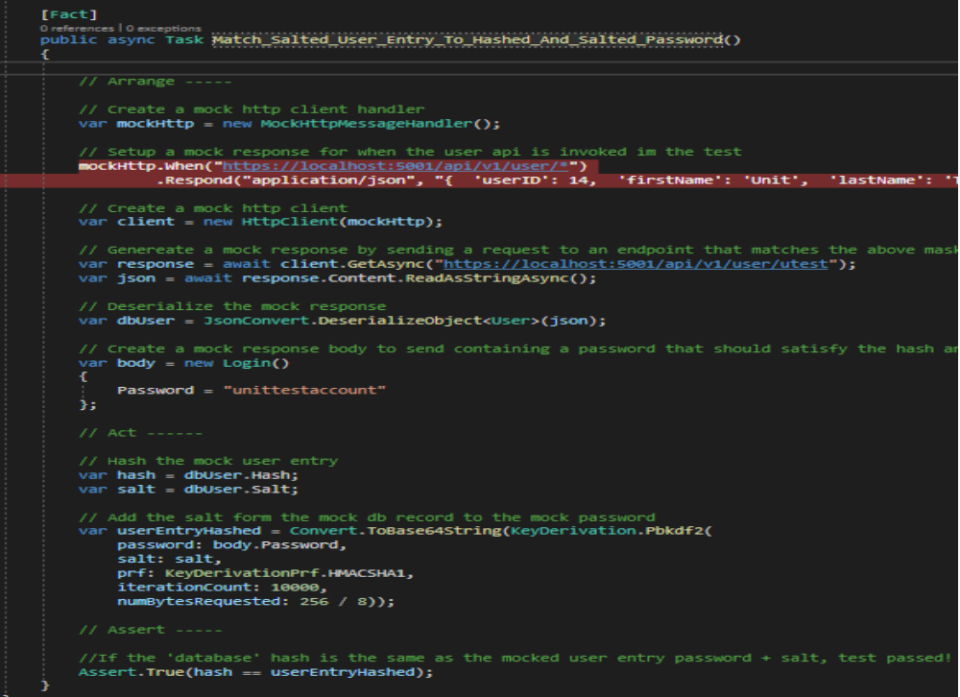

The second test, Fail_On_Bad_User_Entry() validates that an invalid password that is hashed and salted DOES NOT match a fixed salted hashed password like it should during live operation:
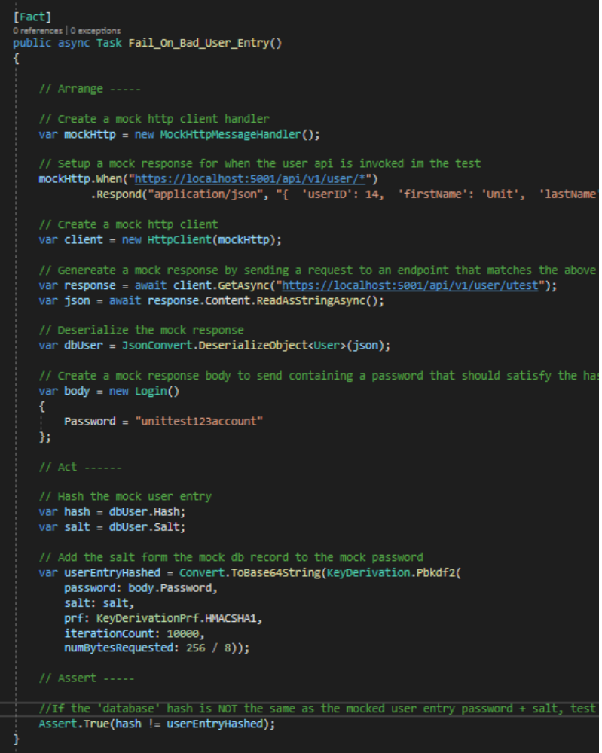

C.3 – RESULTS OF TEST PLAN
All tests have ran successfully, proving that the password hashing and salting routine works and that bad user entry will not allow entry into the UI:
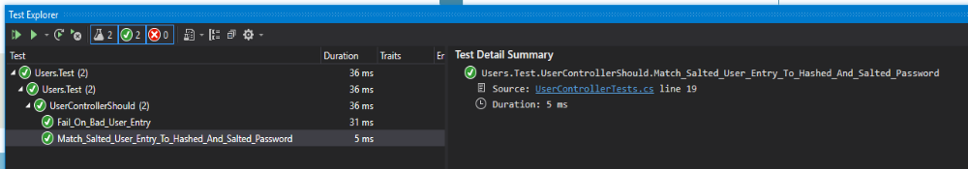

C.4 Specific requirement mappings from WGU task list SECTION B
Polymorphism -
Each controller is using polymorphism with its public API get and post methods where necessary. This can be witnessed by opening the dotnetcore AccountsReceivable microservice project, opening the Controllers folder, and opening ArController.cs. You will see two methods with different method signatures named GetReport, and two methods with different method signatures named GetAr. This technique is used in each of the controllers in each of the projects.
Inheritance -
The strategy pattern is utilized with the HttpClientSvc Service in the Services folder of the C# AccountsReceivable project. It inherits its IHttpClientSvc interface to allow it to be injected via dependency injection so that ARController can make HTTP calls to other microservices.
Each C# controller inherits ControllerBase to be able to enable MVC routing for it's API.
In each microservice, there is a TimeStampable.cs file under the Models/Data folder which other models (AR.cs for instance) use to add timestamp and user information to its data set.
Encapsulation -
Encapsulation is used, most notably in ArController in the AccountsReceivable project, where private methods are called by public methods which do work for the API controller. For instance, the GetTotalsReport public method calls the SetDto and SetList private methods to return data to the end user without the user being able to access SetDto and SetList methods directly.
ArController is also using encapsulation to allow the controller to access _httpClientService to be able to make HTTP calls, which is encapsulated as private and unreachable by end users.
Also found within ARController is a set of private dictionaries that contain mapping data that the controller needs to respond with names and values instead of numbers to the end user. These methods cannot be accessed externally.
All properties in all models are implemented with abbreviated C# getter/setter syntax.

Error handling -
Errors are caught at in the API endpoints as soon as a response is sent and determined to be bad. If it is bad, the API returns the appropriate HTTP error code for the circumstance so that the UI can respond appropriately.
Certain error conditions in the React code are shown when problem are detected. For instance, look at lines 215 to 229 in src/ArController.js in the React app. Here we see an error 400 being detected from the API and the React UI responding with a friendly error message rather than crashing.

Validation -
In terms of validation, the react ui has checkpoints that are made to prevent bad API calls in create/edit modes. The users is guided into success and even if the user could get through with bad data, the app will throw a friendly "cannot complete the action" message in most cases.
Date validation:
Start Date must be before End Date
Start Date must have a value
End Date must have a value
Currency validation:
Currency fields must have no more than two decimal places
Currency fields must be numeric
Currency fields must be greater than or equal to 1
Currency fields must have a value
Create new record validation:
Project, Director, Owner, Site, Cost Center must all be filled out in addition to all of the above conditions being in place for currency and date validation.
Edit record validation:
All fields besides comments must be filled out and all of the above conditions must be in place for currency and date validation.

Security:
Users passwords in the login screen are sent using best standards - in API POST body, over SSL (when we reach our production environment) to mask plaintext passwords.
Passwords are stored in the database as hashed which are hashed using an HMACSHA1 / 10000 iteration 256-bit subkey. Password salts are stored in the database as well (as per standard industry practice) with a 128-bit salt using secure PRNG. When logging in, users have their passwords combined with a salt and then encrypted and compared to the database copy to ensure secure access.

